MOUTNAINOUS PROTECTED BIODIVERSE AREA CALCULATION OVERVIEW

The goal of this project was to measure progress towards SDG 15.4.1 --which is a measure of biodiversity protection in mountainous regions. To do this we initially adapted code from an organization called Birdlife International, and then ran another calculation at a finer resolution using the GMBA mountain inventory. The three main datasets (mountain range, biodiversity areas, and protected areas) are all shapefiles. The main result is the output of [Protected KBA Area / Total KBA Area] in each mountain range. In the example below, this would be the area of the orange outlined purple, and the total area of all the purple.

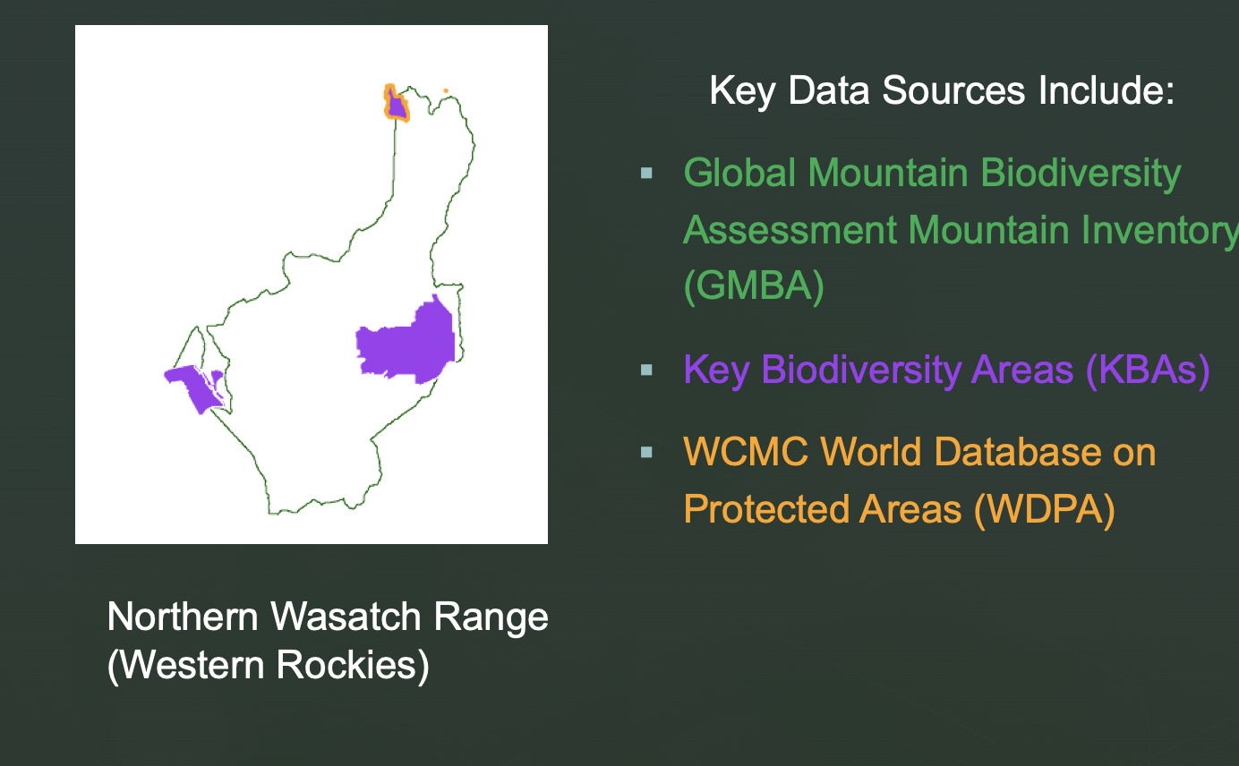

We have previously aggregated the results to larger mountain ranges and created static images like the one below. However, since we have data on the initial year a protected area was created, we could create a timeseries of percent coverage over time.

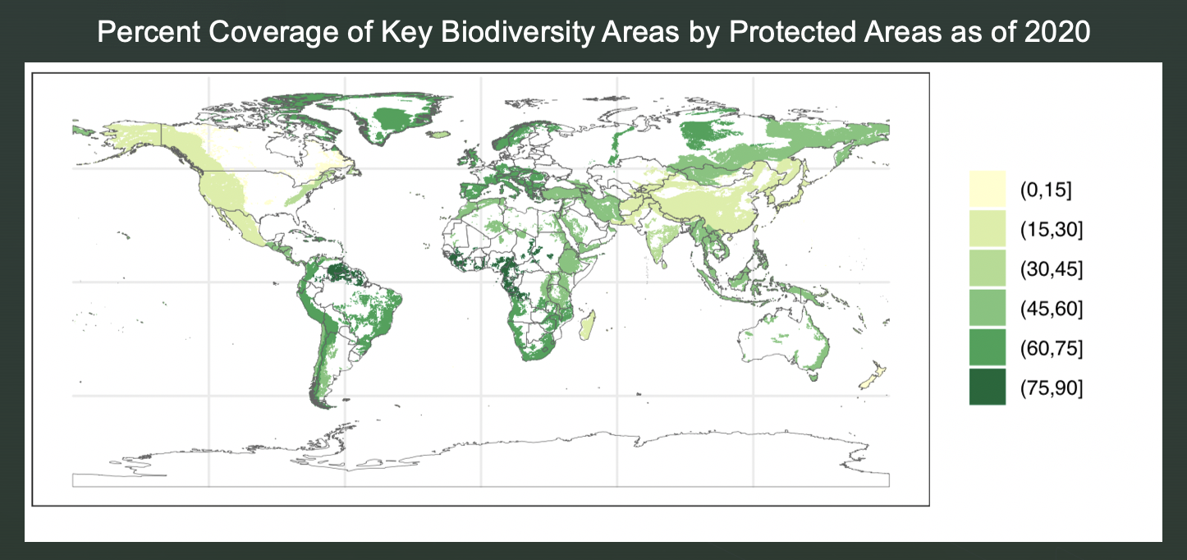

Scroll down for an example of the output (I’ve also attached the full file to the email). Note that the percPA column is how much additional coverage there is each year. So the sum of all the percPA entries for any given SitRecID is the total coverage as of the latest date. (e.g. coverage of SitRecID 35 is 30% in 1973, and 99.7% in 1991)

